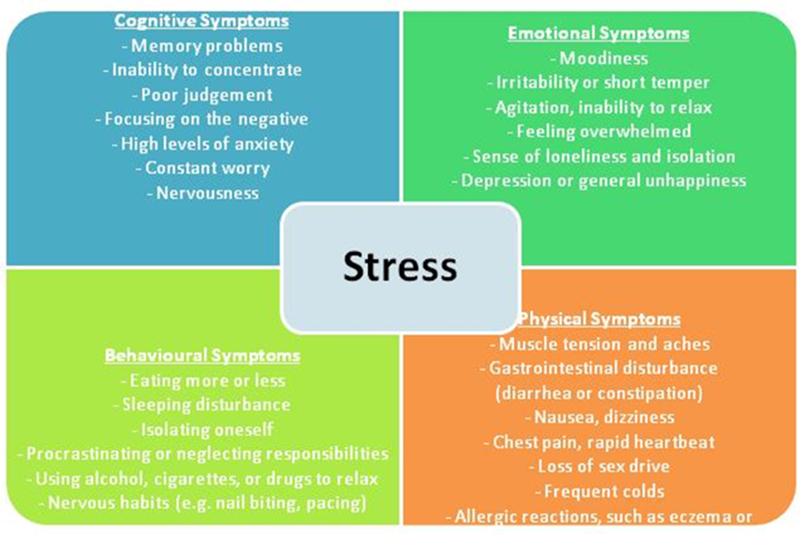

Four Main Balances =Where do you put your TIME /ENERGY /MONEY
Track a full week of 168 hours and see where you are out of balance.

